**RUMOR MILL : TRACKING VIRAL RUMORS THROUGH TEXTUAL ANALYSIS**

**Computer Science and Engineering (AIML)**

By

DURGAM AJAY NEHRUBHAI (20D01A6638)

MAMIDALA SAI PRASAD (20D01A6217)

**College : St Mary’s Group of Institutions Hyderabad**

**_________________________________________________**

**ACKNOWLEDGEMENT**

## ________________________________________________________

With the guidance and assistance of numerous well-wishers, an endeavor over a lengthy period of time can be effective. We would like to take this time to let everyone know how much we appreciate them.

In the beginning, we'd like to express our gratitude to our Developer amyjoy exson, who is a Professional Developer at Coaaps.ai in the field of Data Science, for their invaluable support and direction throughout the project's implementation.

We wish to express our sincere thanks and gratitude to our HR’S, **Blessy Mam and Preeti Mam**, Who are the HR of Coaaps.ai in the field of Data Science for the stimulating discussions, in analyzing problems associated with our project work, and for guiding us throughout the project. Project meetings were highly informative. We express our warm and sincere thanks for the encouragement, untiring guidance, and confidence she has shown in us. We are immensely indebted to her for her valuable guidance throughout our project.

**TABLE OF CONTENT**

## ________________________________________________________

**LIST OF ABBREVATIONS** -------------------------------------------------------**VII**

**LIST OF FIGURES** **VIII**

**LIST OF GRAPHS** **IX**

**LIST OF TABLES** **X**

**ABSTRACT** **XI**

**INTRODUCTION** -------------------------------------------------------------------- **1**

Introduction **--------------------------------------------------------------------** 1

Natural Language Processing -------------------------------------- 2

### Fake News Detection ------------------------------------------------ 3 Problem Statement------------------------------------------------------------- 4

Objectives ---------------------------------------------------------------------- 5

Methodology ------------------------------------------------------------------- 6

Dataset ----------------------------------------------------------------- 6

Flowchart -------------------------------------------------------------- 10 Algorithm ------------------------------------------------------------- 11

**LITERATURE SURVEY**------------------------------------------------------------**13**

**SYSTEM DEVELOPMENT** --------------------------------------------------------**15**

System Configuration **---------------------------------------------------------**15

Data Pre-processing -----------------------------------------------------------15

Design of Project **--------------------------------------------------------------**18 Sample Code **-------------------------------------------------------------------**19

**RESULT AND EXPERIMENTAL ANALYSES** ------------------------------- **40**

Models applied and their result **----------------------------------------------** 40

**CONCLUSIONS** -----------------------------------------------------------------------**50**

### Conclusions ---------------------------------------------------------------------50 Future Scope --------------------------------------------------------------------51

**REFERENCES** ------------------------------------------------------------------------- **52**

**APPENDICES**--------------------------------------------------------------------------- **54**

# LIST OF ABBREVIATIONS

## ________________________________________________________

### SHORT FORM MEANINGS

**TFIDF** = Term Frequency - Inverse Document Frequency

**SVM** = Support Vector Machine

**DT** = Decision Tree

**GBC** = Gradient Boosting Classifier

**LR** = Logistic Regression

**RFC** = Random Forest Classifier

**CV** = Count Vectorizer

**FIG** = Figure

# LIST OF FIGURES

**____________________________________________**

**Fig. 1:** Deep Learning vs Machine Learning vs Artificial Intelligence

**Fig. 2:** Comparison of Fake and Real news

**Fig. 3:** Flowchart

**Fig. 4:** Fake.csv and True.csv

**Fig. 5:** Design of the Project

**Fig. 6:** Importing Libraries

**Fig. 7:** Fake.csv

**Fig. 8:** True.csv

**Fig. 9:** Checking Shape and Merging the Data

**Fig. 10:** Distribution of Classes

**Fig. 11:** Generate word cloud for the combined

**Fig. 12:** Adding Class, Merging Columns, drop columns,

**Fig. 13:** Resetting the Index

**Fig. 14:** Pre-Processing task of words

**Fig. 15:** Plotting the distribution of text lengths

**Fig. 16:** Plotting the most frequent words for the combined dataset

**Fig. 17:** Splitting the Data and Checking there shape

**Fig. 18:** Feature Extraction Using TfidfVectorizer

**Fig. 19:** Logistic Regression

**Fig. 20:** Support Vector Machine

**Fig. 21:** Decision Tree Classifier

**Fig. 22:** Gradient Boosting Classifier

**Fig. 23:** Random Forest Classifier

**Fig. 24:** Testing

**Fig. 25:** Output

**Fig. 26:** Confusion Matrix from Support Vector Machine

**Fig. 27:** Logistic Regression [7]

**Fig. 28:** Confusion Matrix from Logistic Regression

**Fig. 29:** Decision Tree [8]

## Fig. 30: Confusion Matrix from Gradient Boosting Classifier

**Fig. 31:** Confusion Matrix from Random Forest Classifier

**Fig. 32:** Web Browser Output

# 

# LIST OF GRAPHS

**____________________________________________**

**Graph 1:** Frequent words in Fake news

**Graph 2:** Frequent words in Real News

**Graph 3:** Frequent bigrams

**Graph 4:** Frequency of subject of the news

**Graph 5:** Frequency of subject of the news

**Graph 6:** Fake and Real News

**Graph 7:** Frequency of words in fake news

**Graph 8:** Comparison of the accuracies of different models

**LIST OF TABLES**

**____________________________________________**

**Table 1:** Classification Report of SVM

**Table 2:** Classification Report of LR

**Table 3:** Classification Report from DT

**Table 4:** Classification Report of GBC

**Table 5:** Classification Report of RFC

# ABSTRACT

**____________________________________________**

Fake News has become one of the major problems in the existing society. Fake News has high potential to change opinions, facts and can be the most dangerous weapon in influencing society.

The proposed project uses NLP techniques for detecting the 'fake news', that is, misleading news stories which come from non-reputable sources. By building a model based on a Random Forest Classifier algorithm, the fake news can be detected. The data science community has responded by taking actions against the problem. It is impossible to determine whether the news was real or fake accurately. So, the proposed project uses the datasets that are trained using the count vectorizer method for the detection of fake news and its accuracy will be tested using machine learning algorithms.

In this research, we concentrate on how to spot fake news in internet news sources. We are dedicated in two ways. In order to determine the percentage of correct news that is phony, we will use multiple datasets of actual and fake news. We provide a thorough description of the selection, justification, and approval process as well as a few exploratory analyses on the observable evidence of etymological differences in false and legitimate news material. In order to create precise false news identifiers, we focus a lot of learning studies. Additionally, we provide close examinations of the automatic and manual evidence of bogus news. Python can be used to spot fake news posted on social media.

CHAPTER-1

INTRODUCTION

**___________________________________________**

## 1.1) Introduction

Machine learning (ML) is the study of the statistical models and methods used by computers to do certain tasks devoid of explicit instructions and in favour of patterns and inference. As part of artificial intelligence, it is viewed. Without explicit instructions, machine learning algorithms construct a mathematical model using sample data, or "training data," in order to provide predictions or judgements. Computational statistics, which focuses on computer-aided prediction, and machine learning have a lot in common. Machine learning may benefit from the ideas, practises, and fields of application that come from the study of mathematical optimisation.

The quantity of modifications that the data goes through is referred to as "deep learning" in this context. The credit assignment path (CAP) depth is significant, especially for deep learning systems. The series of changes that take place from input to output make up the CAP. CAPs define the possible causal connections between input and outcome. For a feed-forward neural network, the depth of the CAPs is equal to the depth of the network plus one, given that the output layer is also parameterized. Since a signal can pass through a layer more than once in recurrent neural networks, the CAP depth may be limitless.

Fake news, to put it simply, is information that is untrue. whether or whether it is a ccurate. Fake news contains verifiable erroneous information. Many significant companies, even government agencies, are working to address issues related to false news. However, given that millions of articles are produced or purged every minute in this age, they are neither responsible nor humanely feasible because they rely on manual human detection. A machine learning algorithm that creates a trustworthy automated index score or rating for the authenticity of various publications and can assess whether the news is true or misleading may provide a solution to this problem.

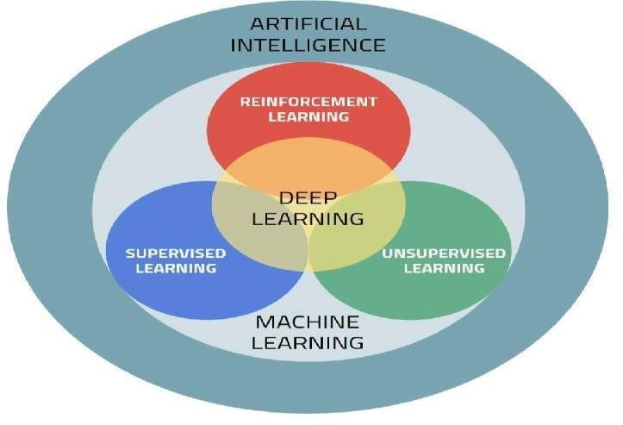

**Fig. 1: Deep Learning vs Machine Learning vs Artificial Intelligence**

## 1.1.1) Natural Language Processing (NLP)

The study of how computers interact with human (natural) languages is known as natural language processing, or NLP, and it is a branch of computer science and artificial intelligence that focuses on instructing computers to efficiently analyse massive volumes of natural language data. In the fields of linguistics, computer science, information engineering, and artificial intelligence, natural language processing (NLP) studies how computers interact with human (natural) languages. Its major goal is to instruct computer programmers in how to study and analyse vast amounts of natural language.

## 1.1.2) Fake News Detection

With the rising use of social media platforms, false news has become a severe problem in recent years. Finding fake news is a difficult problem that necessitates the use of several computer techniques, such as data mining, machine learning, and natural language processing. In this abstract, the current state of false news detection will be discussed, along with its challenges and potential solutions. Finally, it will consider how cutting-edge technology like blockchain and artificial intelligence may be used in the future to improve the efficiency and precision of fake news detection.

As a result, there is a larger than ever need for accurate and reliable techniques to distinguish fake news. The field of fake news detection has rapidly evolved as a result of researchers and engineers developing a number of techniques and tactics to identify and combat misleading information. These methods include human factchecking by educated professionals as well as sophisticated computers that use machine learning to examine and classify news content. Automated processes are also a part of them.

It is important to research and create fake news detection, but it is also a challenging and complex problem. The ability to recognise fake news requires knowledge of linguistic nuance, social and cultural contexts, and the complex network dynamics of online communication. Despite these challenges, work has been done to establish effective methods for spotting false news, and the area is still developing as new tools and technology are created.

## 1.2) Problem Statement

Both benefits and drawbacks come with reading the news. On the other hand, news is actively sought for and consumed since it is easily available, inexpensive, and quickly spread. It makes it possible for "fake news," or negative news with blatantly inaccurate material, to be widely disseminated.

As a result, research into the detection of bogus news has recently made significant strides. First off, identifying fake news just on the basis of the content is challenging and nontrivial since it is purposefully designed to lead people to accept incorrect information.

## 1.3) Objective

Our project's primary goal is to determine the veracity of news in order to determine if it is real or phoney. the development of a machine learning model that would allow us to recognise bogus information.

It can be difficult and difficult to identify fake news only based on its content since it is intentionally produced to influence readers to believe false information.

By applying a range of methods and models, machine learning makes it easy to detect bogus news. Additionally, to examine the relationship between two words, we will apply deep learning-based NLP.

You may eliminate stop words using this method as well.

**1.4) Methodology**

## 1.4.1) Dataset

Two datasets are available. a mix of the two. There are 44898 news stories total in the csv file, which is a sizable quantity. While the true dataset only comprises 21417, the fraudulent dataset has 23481. This data collection is accessible at:

The dataset contains the following attributes:

The following elements are included in a news article: • Id: Special ID for News Article;

* title;
* text;
* Subject;
* It describes the topic of the news.
* Date: It provides news's publication date.
* The conclusion that the information might not be trustworthy.

0: Untrustworthy or False News

1: Reliable or Accurate News

First of all, the dataset is quite balanced, as we have shown. There are 21417 accurate news items and 23481 false news pieces in it. This is a beneficial feature of the dataset.

It will aid models in making objective judgments.

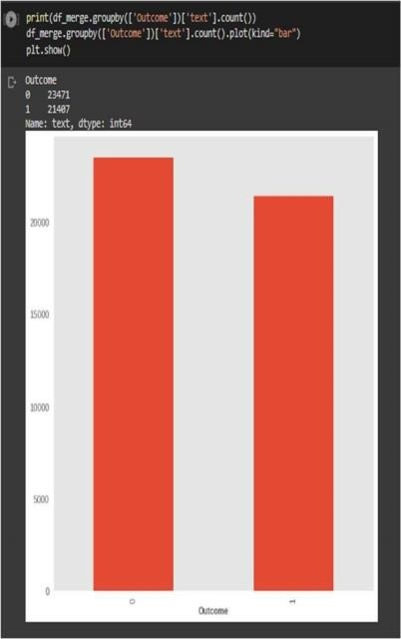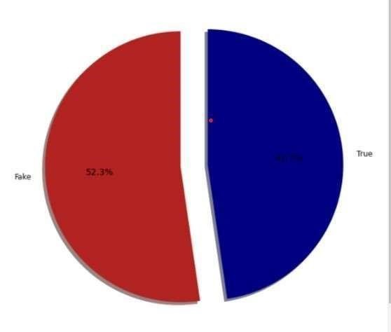

**Fig. 2: Comparison of Fake and Real news**

The dataset has undergone some processing, and as was indicated, stop terms have been included. The most common words in the dataset are "the," "to," "of," "and," etc.

The top 20 terms in the sample were as follows before stop words were eliminated:

.

## Fake.csv

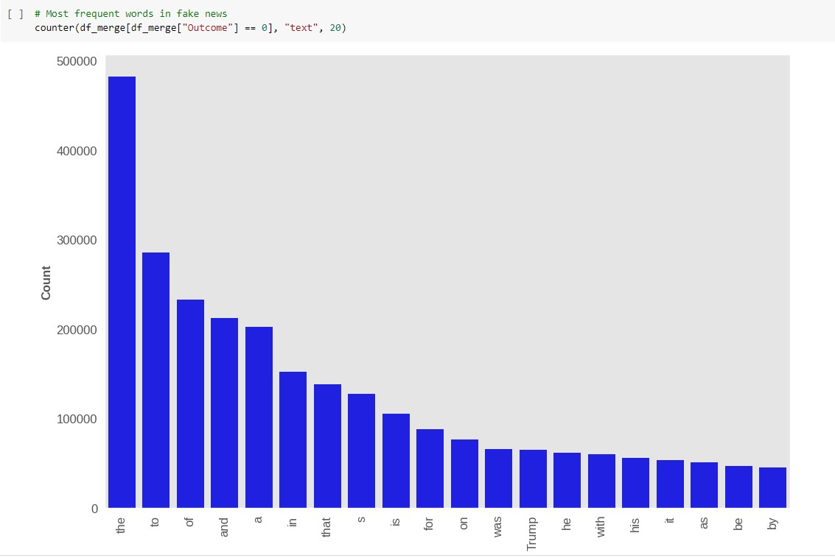

**Graph 1: Frequent words in Fake news**

**True.csv**

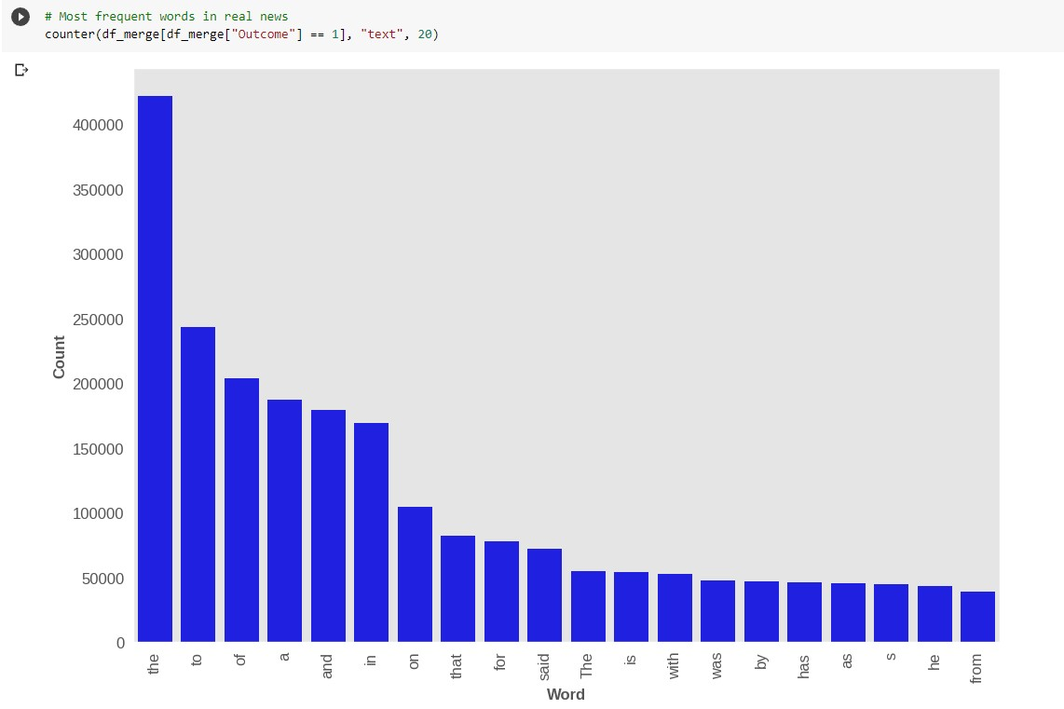

**Graph 2: Frequent words in Real News**

The terms "said," "mr," "trump," "new," "people," and "year," which are now the most popular ones, can provide the models important information.

We also examined the bigrams in the dataset to have a better understanding of the news story subjects. Before stop words are removed, the topics of the news stories are not at all clear. As a result, removing stop words makes it simpler to comprehend the news reports' themes.

The graph below displays the top 20 bigrams from the dataset before stop words are removed. As one can see, often used phrases like "of the," "in," and "to the" do not help one comprehend the content of the story.

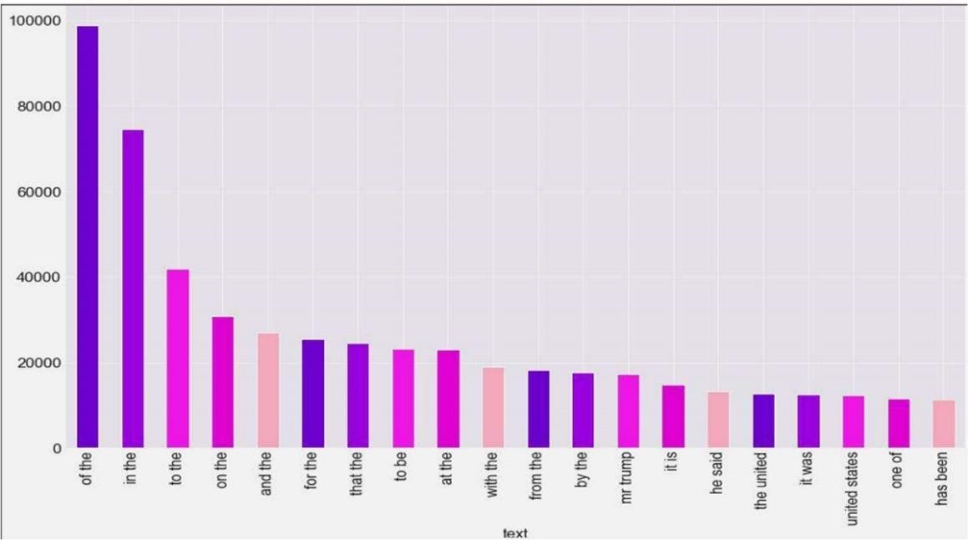

**Graph 3: Frequent bigrams**

**To display the data, we plotted the frequencies of subject of the news:**

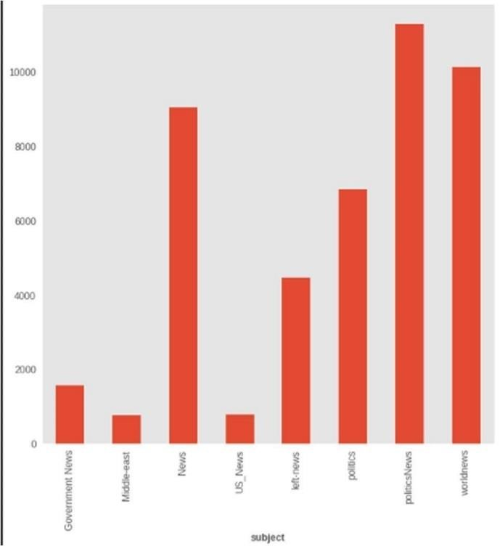

**Graph 4: Frequency of subject of the news**

**1.4.2) Flowchart:**

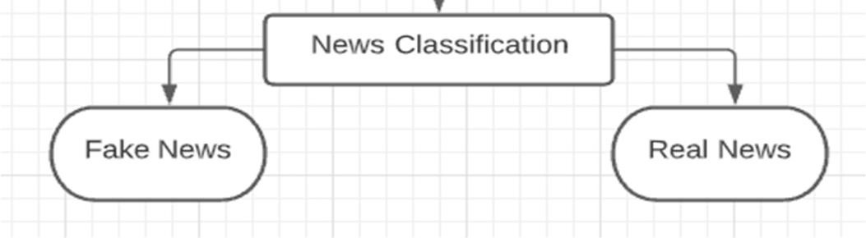

**Fig. 3: Flowchart**

## 1.4.3) Algorithm for The Proposed System Step 1: Pre-processing

* Load the dataset of news items with their labels, whether they are true or false;
* Clean the text by eliminating punctuation and stopwords; ▪ Divide the dataset into training and testing sets.

## Step 2: Count Vectorization

* Count Vectorizer from the Sklearn toolkit may be used to transform text data into numerical data.
* Produce a document-term matrix showing the frequency of each word used in each document.
* Fit the Count Vectorizer using the training set, then convert the data.
* Utilise the testing set to change the data.

## Step 3: TFIDF Vectorization

* Utilise the Tfidf Vectorizer in the Sklearn package to turn the text data into numerical data.
* Use the training set to fit the Tfidf Vectorizer and convert the data.
* Create a document-term matrix that depicts the significance of each word in each document.
* Utilise the testing set to change the data. **Step 4: Training the Models**
* Utilise the data that has been modified by Count Vectorizer and Tfidf Vectorizer to train a variety of models, including Naive Bayes, Logistic Regression, Support Vector Machines (SVM), Random Forest, etc.
* Fit the models using the training set.
* Use the testing set to predict the news article labels.
* Determine each model's accuracy score using the actual and projected labels.

## Step 5: Confusion Matrix

* The confusion matrix displays the amount of true positives, true negatives, false positives, and false negatives for each model, allowing you to assess each one's performance.
* Measurements like accuracy, recall, and F1-score may be calculated using the confusion matrix.

## Step 6: Accuracy

* Determine each model's accuracy by comparing its predicted labels to its actual labels.
* The accuracy measures the proportion of news stories that were accurately identified as being true or false.
* Evaluate the accuracy of various models to find which one is most effective at spotting fake news.

## Step 7: Representing the Output in Web Browser using Streamlit

* Use the Streamlit Python module to build an interactive web application for showcasing the outcomes of false news detection models.
* Create a user interface that clearly displays the confusion matrices, accuracy of each model, and other performance indicators.
* Provide tools that allow users to submit their own content for categorization and display the key terms and phrases used to categorise news items, among other capabilities.

CHAPTER-2 LITERATURE SURVEY

**___________________________________________**

A. S. A. Ahmed, A. Abidin, M. A. Maarof, and R. A. Rashid [1] is only a survey and does not contain any experiments or findings. Instead, the study offers a thorough analysis of the many false news detection techniques put out in the literature, as well as their advantages and disadvantages, as well as the datasets employed for testing. In terms of feature selection, feature extraction, classification algorithms, and assessment measures, the authors examine and contrast the methodologies utilised by various research. In the area of false news identification, they also emphasise the difficulties and potential avenues for further study. The article makes use of a number of datasets, including those from BuzzFeed, LIAR, FakeNewsNet, and PolitiFact.

S. Asghar, S. Mahmood, and H. Kamran, "Fake news detection using machine learning [2] the article also addresses a number of datasets that have been used in studies on the identification of fake news, including the LIAR dataset, the Fake News Challenge dataset, and the BuzzFeed News dataset. According to the authors, ensemble learning-based algorithms had the greatest results on the LIAR dataset, with accuracy rates of up to 78%. On the BuzzFeed News dataset, on the other hand, deep learning-based methods perform better, achieving an accuracy of up to 91%.

J. H. Kim, S. H. Lee, and H. J. Kim, "Fake news detection using ensemble learning with context and attention mechanism,"[3] For their experiments, the authors employ two datasets: the Celebrity dataset and the LIAR dataset. To capture both local and global aspects of news items, the proposed model combines convolutional neural networks (CNNs) with recurrent neural networks (RNNs). The experimental findings demonstrate that the suggested model outperforms numerous baseline models and reaches an accuracy of up to 73.7%, reaching state-of-the-art performance on both the LIAR and Celebrity datasets.

**]** M. F. Hossain, M. M. Islam, M. A. H. Khan, and J. J. Jung, "Fake news detection using hybrid machine learning algorithms," [4] the LIAR dataset, a gold standard for research on fake news identification, is used by the authors. It consists of statements that are either labelled as true or false and also include extra labels for the degree of falsehood. The Support Vector Machine (SVM), Multinomial Naive Bayes (MNB), and Random Forest (RF) machine learning techniques are used in the suggested hybrid method. To choose the most pertinent characteristics for each algorithm, the authors employ a feature selection technique known as Chi-Square. They then integrate the results of the three algorithms and arrive at a final forecast using a weighted voting system. According to the experimental findings, the suggested hybrid technique works better than each individual algorithm and a number of baseline models, obtaining an accuracy of up to 72.28%.

S. S. Ghosh, A. Mukherjee, and N. Ganguly, "A multi-perspective approach to fake news detection," [5] in their research, the authors used the FakeNewsNet dataset together with another one. Word embedding and term frequency-inverse document frequency (TF-IDF) approaches are used by the authors to extract aspects from the news articles that are content-based. In order to determine the veracity of the news stories based on these attributes, the authors utilise a support vector machine (SVM) classifier. The experimental findings demonstrate that the proposed multiperspective strategy outperforms numerous baseline models and achieves state-ofthe-art performance on the FakeNewsNet and BuzzfeedNews datasets, attaining an accuracy of up to 94.7%.

CHAPTER-3

SYSTEM DEVELOPMENT

**___________________________________________**

## 3.1) System Configuration

Run this project using standard hardware. We utilised an Intel I3 CPU with 8 GB of RAM, a 2 GB Nvidia graphics processor, and 2 cores that have a frequency of 1.7 GHz and 2.1 GHz, respectively, to complete the project. The test phase, which follows the training phase and lasts for around 10-15 minutes, allows for predictions to be made and accuracy to be determined quickly.

**3.2) Data Pre-processing**

## Data Missing Imputation

Missing values in datasets can be a difficulty for some machine learning techniques. Therefore, any missing values in each column of the input data must be found and replaced before we model the prediction problem. Missing The use of data assignment or assignment is made for this.A space (' ') should be used in place of the null value for each attribute. Use this approach instead of removing tuples containing null values.

## Removal of Stop Words

Stop words like "if," "the," "is," "a," and "an," among others, shouldn't be given much weight by a machine learning model because they are common English expressions and don't increase the novelty or believability of any tale. Being present in the dataset may have an impact on the model's forecast because they are often used.

## Removal of Special Characters

The use of special characters in a sentence has no bearing on whether a piece of news is accurate or not. We do this to eliminate all punctuation from the dataset. Regular expressions are used to eliminate all punctuation. A random function was developed to remove special characters, links, extraspace, underlines, etc.

## Lemmatization

The word "play" serves as the origin for other words, including "playing" and "plays." It is possible to carry out a more extensive examination of the term's frequency by swapping out the term's core word with words in other tenses and participles. As a result, we substitute that word for any phrase that only has one source word.

## Count Vectorization

For machine learning algorithms to accept the preprocessed text as input, it must next be encoded as integers or floating-point values. The phrase used to describe this method is feature extraction (or vectorization).

If a vocabulary word is present in the text data, we will add one to the corresponding vector's dimension, which will have the same number of dimensions as our vocabulary. We will add one to the total for each additional instance of that term, leaving zeros in the spots where we didn't see it even once.

## TF-IDF Transformation

In order to create a matrix with TF-IDF values for each feature, we utilise the count vectorized matrix as a transformation.

IDF, or Inverse Document Frequency, or Term Frequency (TF), which is identical to what we previously saw in the Count Vectorizer

Because some words may prove to be incredibly unimportant, word frequency alone might not be accurate. Thus, we employ TF-IDF to maintain harmony between a word's significance and frequency within the text. The acronym TF-IDF stands for term frequency and inverse document frequency.

.

## Fake.csv and True.csv

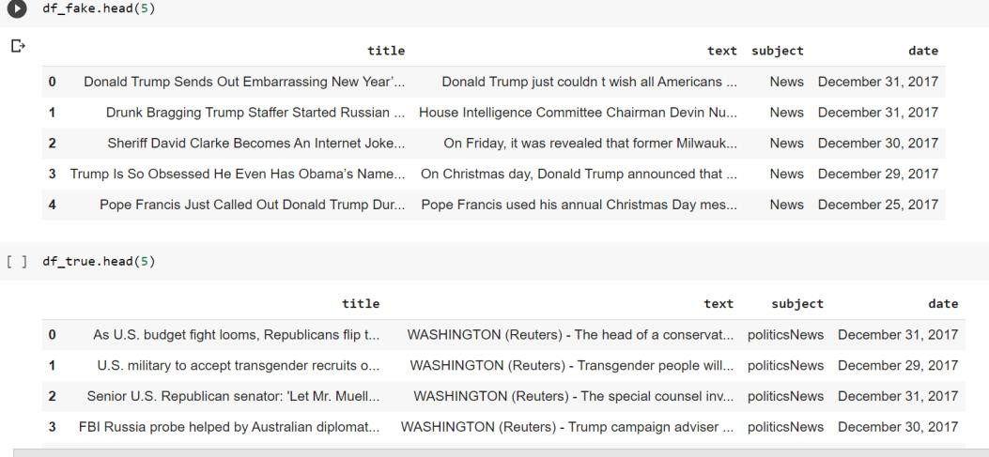

**Fig. 4: Fake.csv and True.csv**

## 3.3) Design of Project

**Dataset:** The first step is to collect or obtain a dataset of news articles, labeled as "fake" or "real". This dataset will be used to train and evaluate the performance of different fake news detection models.

**Preprocessing:** The dataset must now be cleaned up by eliminating any extraneous or irrelevant data, including stop words, punctuation, and digits. Additionally, the text may need to be normalised by making all characters lowercase and eliminating any special characters or symbols.

**Count Vectorizer (BOW):** The Bag-of-Words (BOW) format can be used to transform textual data into numerical characteristics after preprocessing the text. This entails building a matrix where each row represents a news item and each column represents a distinct term from the dataset. The value in each cell indicates how often the term appears in the related art.

**Train-Test Split:** Once we have the BOW matrix, we can split the data into training and testing sets. The training set will be used to train the fake news detection model, while the testing set will be used to evaluate the model's performance on new, unseen data.

**Text-to-vectors (TF-IDF):** In addition to BOW, we can also express the textual data using the Term Frequency-Inverse Document Frequency (TF-IDF) representation. The frequency of the terms in each article as well as their frequency throughout the whole dataset is taken into consideration in this representation. This helps to downplay terms that are prevalent across the whole dataset and to emphasise words that are exclusive to a certain article.

**Models:** After obtaining the numerical features from the text data, several machine learning methods such as logistic regression, decision trees, or neural networks can be employed to train a fake news detection model. The objective of the model is to learn a function that can accurately classify news stories as either "real" or "fake" based on the derived attributes from the text.

**Accuracy and Confusion Matrix:** It's crucial to assess the false news detection model's performance on the testing set after we've trained it. By assessing its accuracy, precision, recall, and F1 score, we may do this. To see how many true positives, true negatives, false positives, and false negatives the model produces, we may also develop a confusion matrix.

**Testing:** We may use the model to categorise fresh and previously unheard news pieces as "real" or "fake" after assessing the model's performance. This entails applying the same feature extraction and preprocessing operations to the fresh data that we did during training. After that, we can apply the trained model to the cleaned-up data to provide a categorization label.

**Result:** Streamlit library of python is used to represent the result in web browser where user input the news and algorithm tell that the news is “Real” or “Fake”.

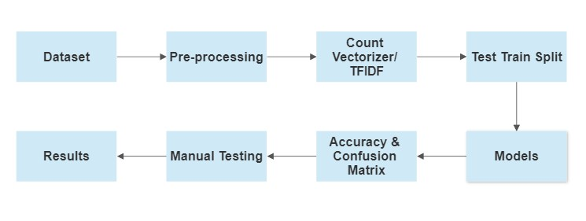

**Fig 5: Design of the Project**

## 3.4) Sample Code

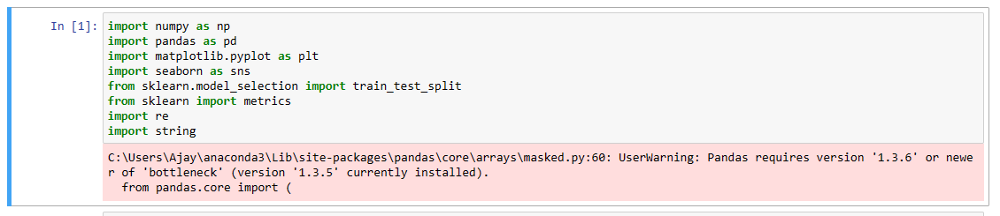

**Fig. 6: Importing Libraries**

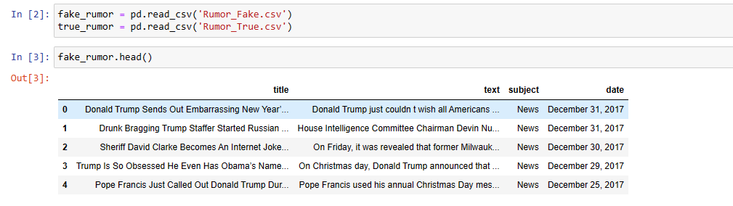

**Fig. 7: Fake.csv**

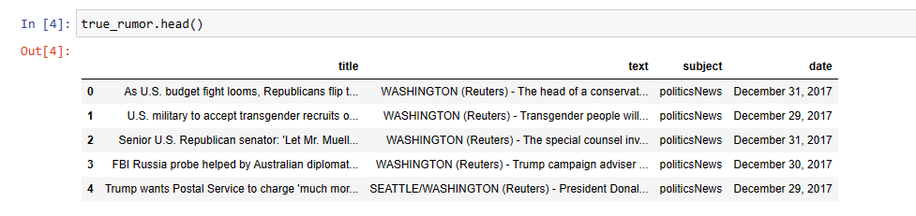

**Fig. 8: True.csv**

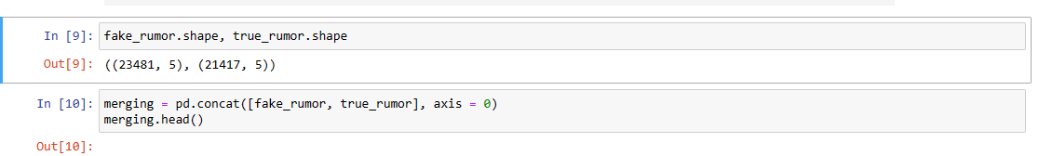

**Fig. 9: Checking shape and Merging the Data**

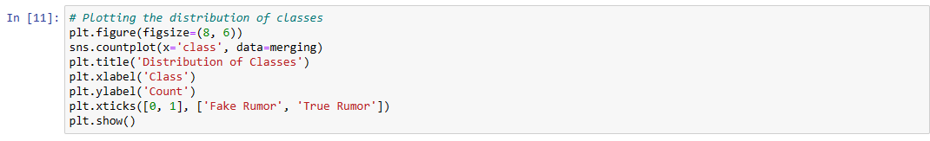

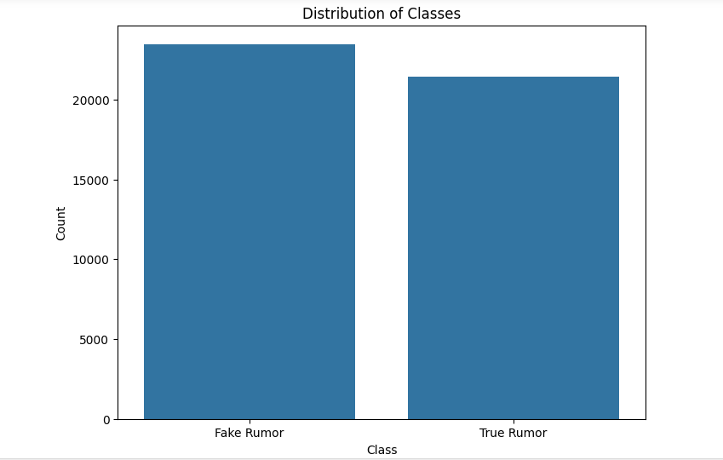

**Fig. 10: Distribution of Classes**

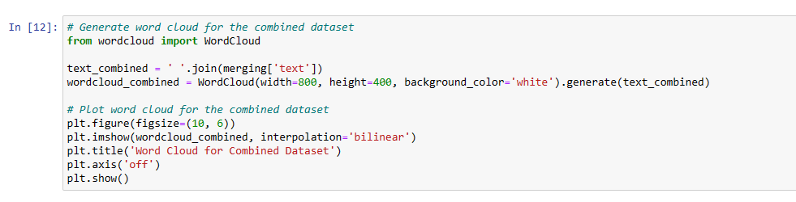

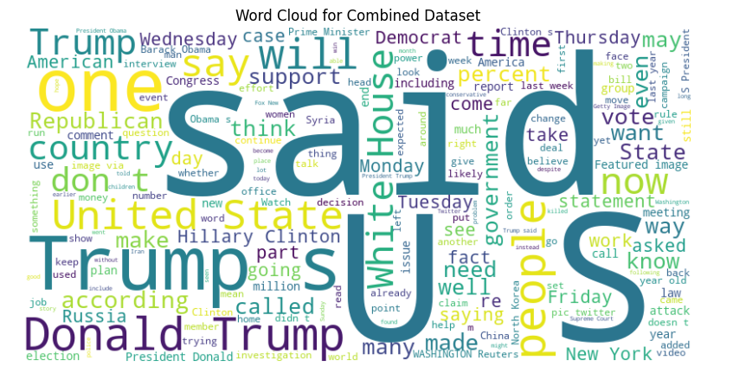

**Fig. 11: Generate word cloud for the combined Dataset**

## Pre-processing of Dataset



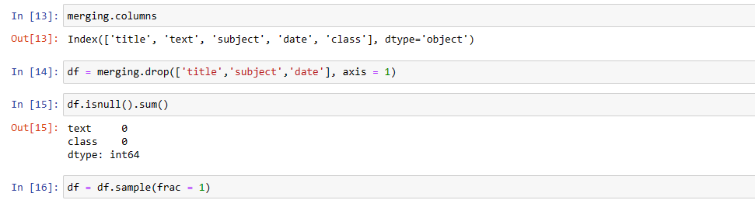

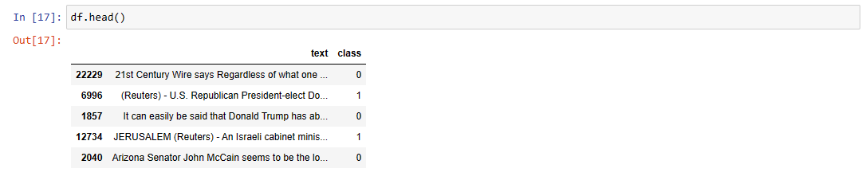

**Fig. 12: Adding Class, Merging Columns, drop Columns,**

**Checking Null values and Frac the data.**

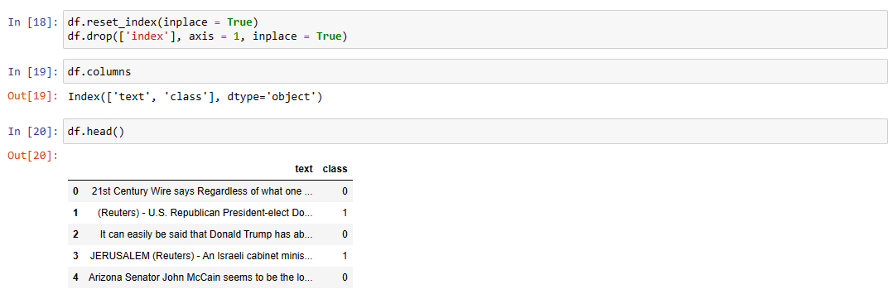

**Fig. 13: Resetting the Index**

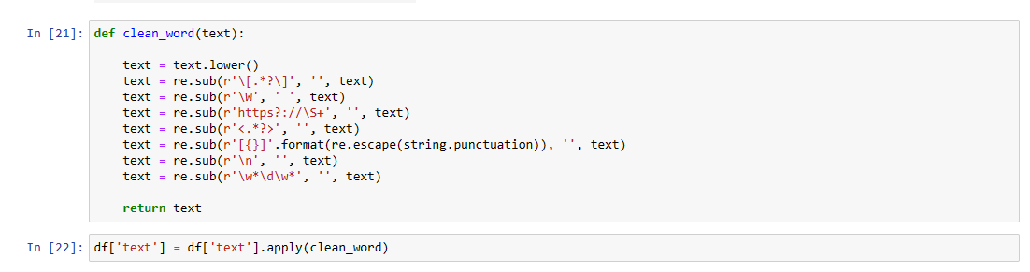

**Fig. 14: Pre-processing task of words**

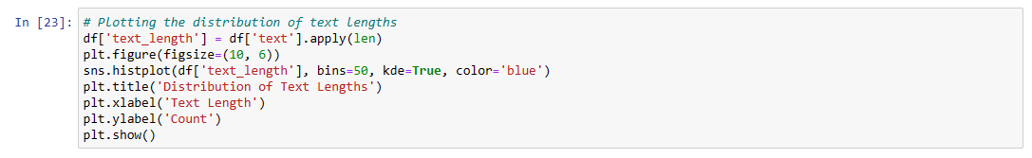

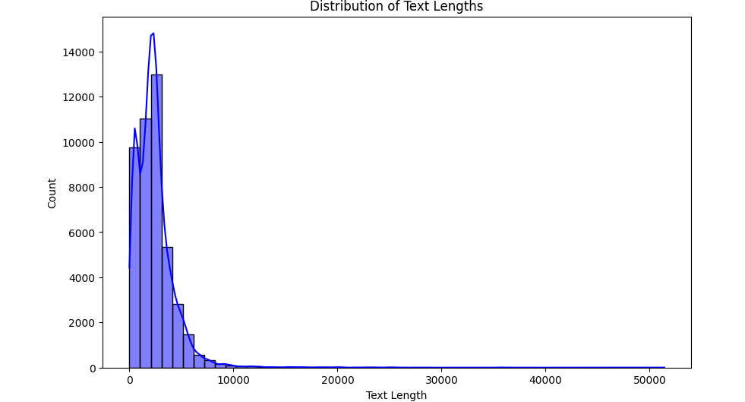

**Fig. 15: Plotting the distribution of text lengths**

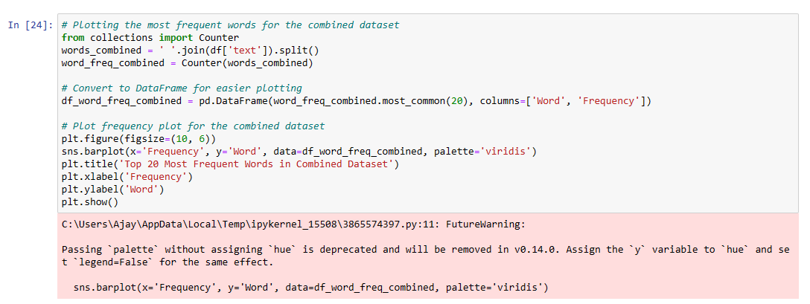

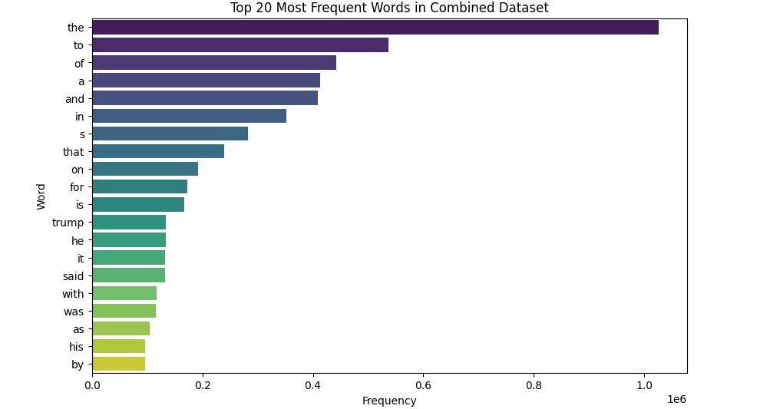

**Fig. 16: Plotting the most frequent words for the combined dataset**

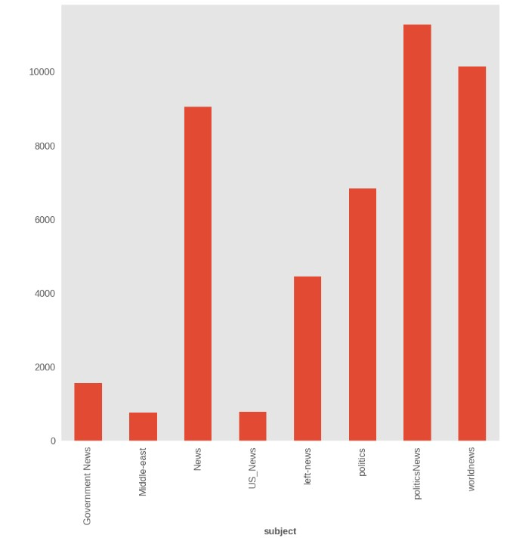

**Graph 5: Frequency of subject of the news**

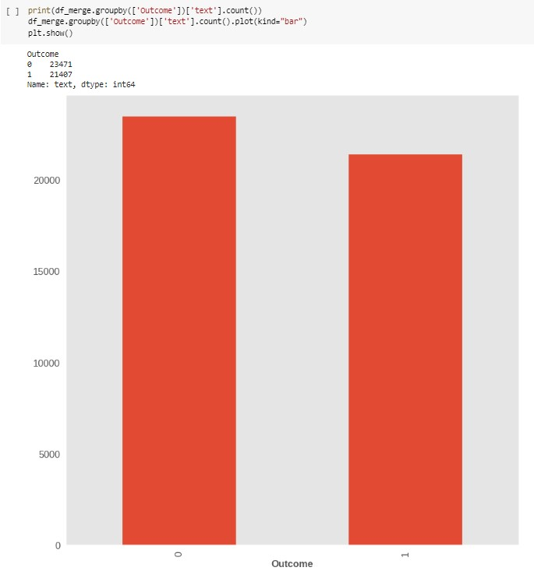

**Graph 6: Fake and Real News**

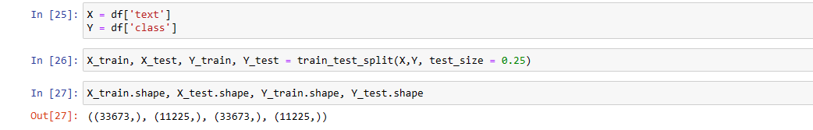

**Fig. 17: Splitting the Data and Checking there shape**

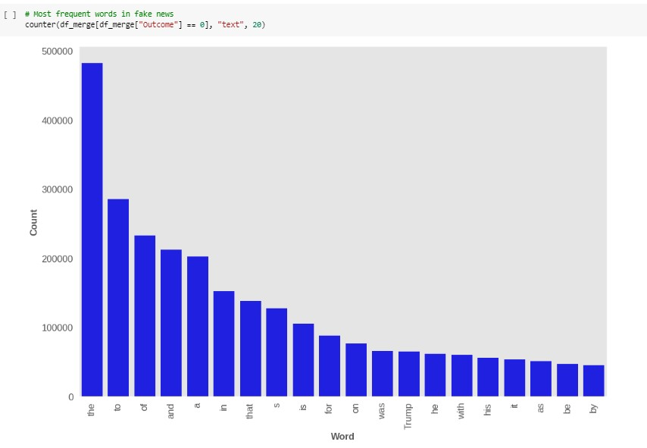

**Graph 7: Frequency of words in fake news**

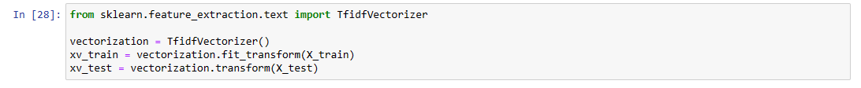

**Fig. 18: Feature Extraction Using TfidfVectorizer**

## Models

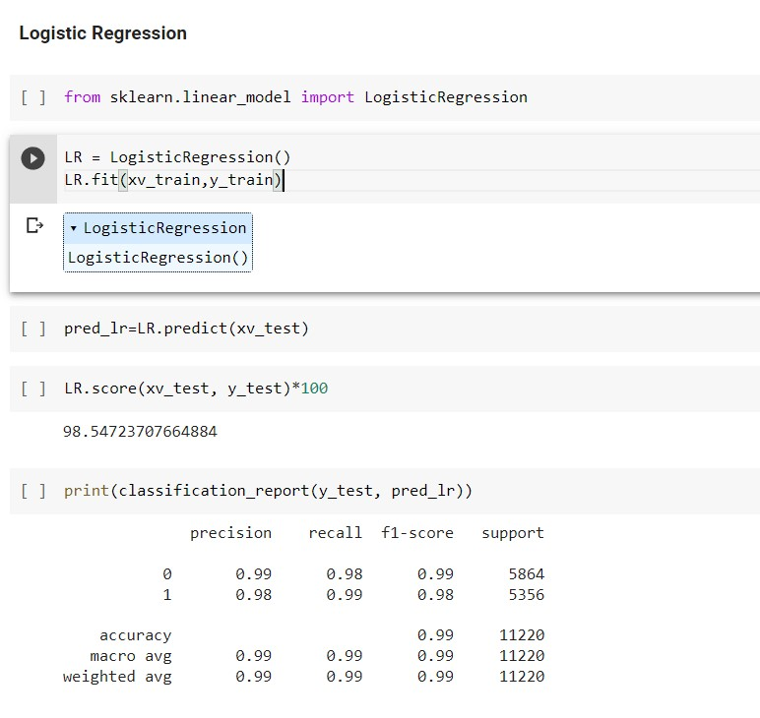

**Fig. 19: Logistic Regression**

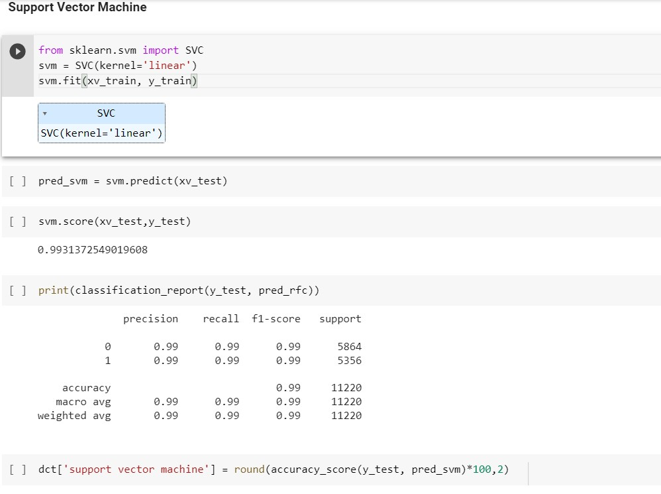

**Fig. 20: Support Vector Machine**

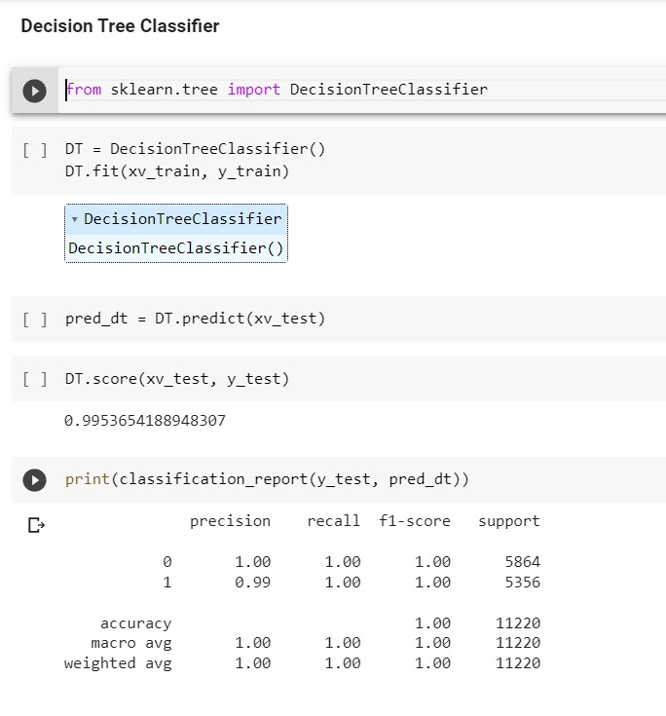

**Fig. 21: Decision Tree Classifier**

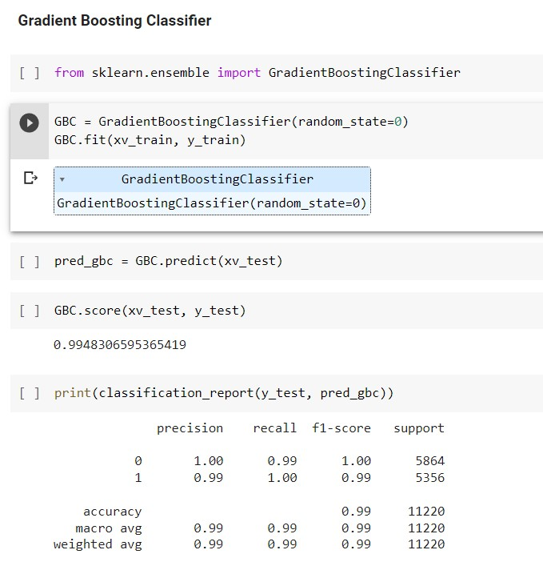

**Fig. 22: Gradient Boosting Classifier**

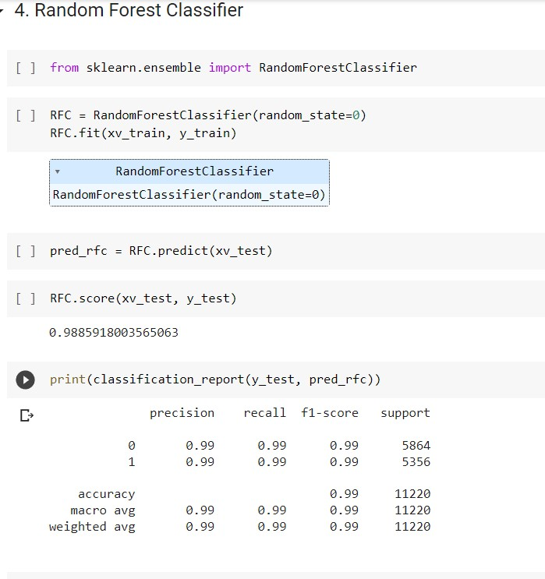

**Fig. 23: Random Forest Classifier**

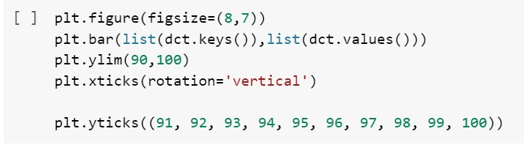

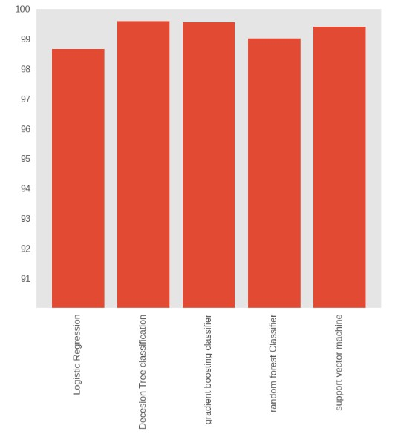

**Graph 8: Comparison of the accuracies of different models**

## Testing

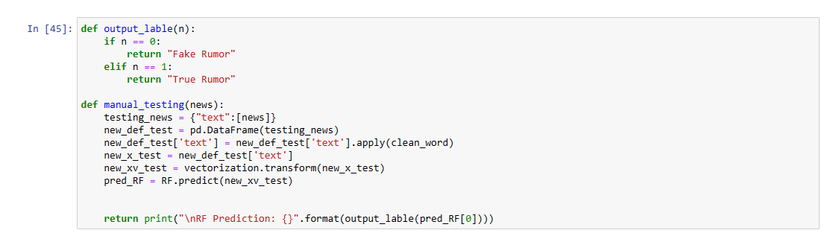

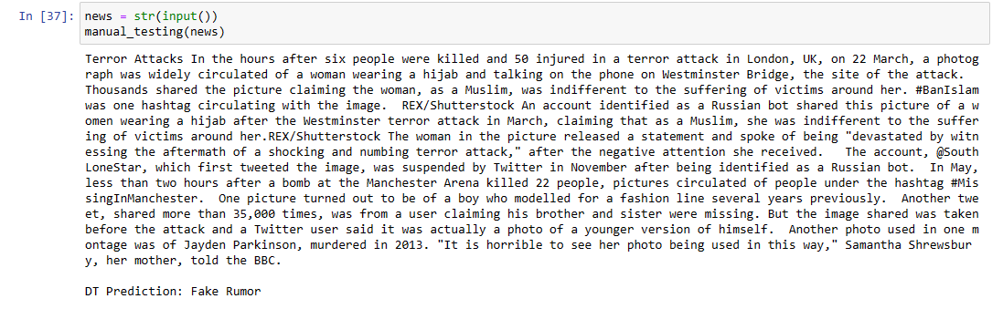

**Fig. 24: Testing**

## Sample Input



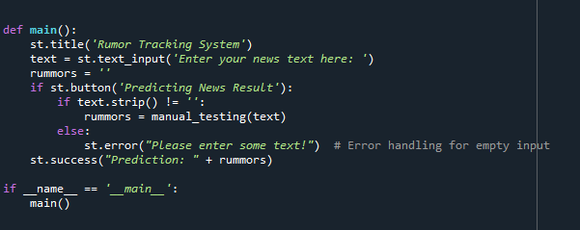



**Fig. 25: Output**

CHAPTER-4

RESULTS AND EXPERIMENTAL ANALYSIS

**___________________________________________**

**4.1) Models Applied And their Results**

## Support Vector Machine (SVM)

* Classification and regression problems are resolved using Support Vector Machine, or SVM, one of the most used supervised learning techniques. It is mostly used, nevertheless, in Machine Learning Classification problems.
* SVM chooses the extreme vectors and points that help build the hyperplane. The foundation of the SVM approach is the support vectors, which are utilised to represent these extreme situations. Take a look at the image below, where a decision boundary or hyperplane is used to classify two separate categories:

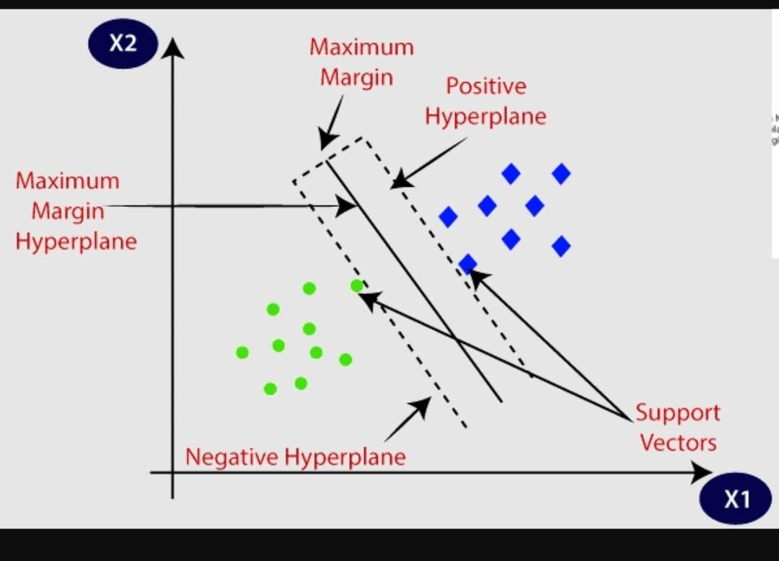

**Support Vector Machine (SVM) [6]**

**Below are the Results from applying Support Vector Machine model:**

**Table 1: Classification Report of SVM**

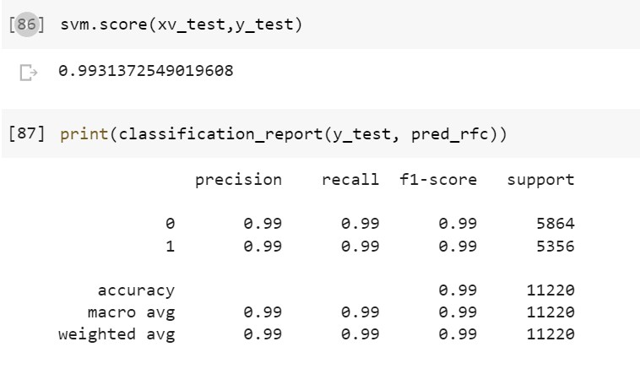

**Confusion Matrix:**

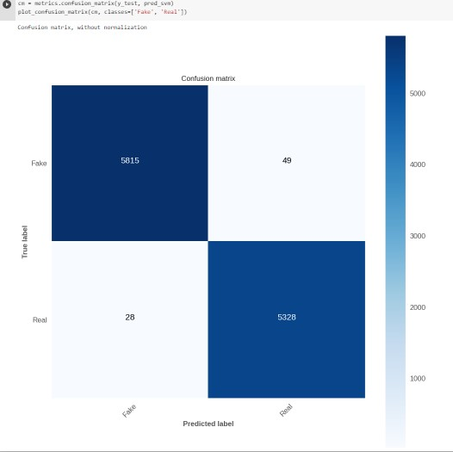

**Fig. 26: Confusion Matrix from Support Vector Machine**

## Logistic regression

* In binary classification issues, where the goal is to predict one of two outcomes, logistic regression is a frequently used approach. Through the use of a sigmoid function, it converts the output of the linear regression into a probability value between 0 and 1, which can then be used to decide whether to classify data by applying a threshold.
* With applications in many areas, including credit scoring, spam filtering, and medical diagnosis, this simple yet reliable algorithm may be taught well on big datasets. However, because it depends on certain presumptions, such as the linearity and independence of the characteristics, it could not work well with highly coupled or nonlinear data.

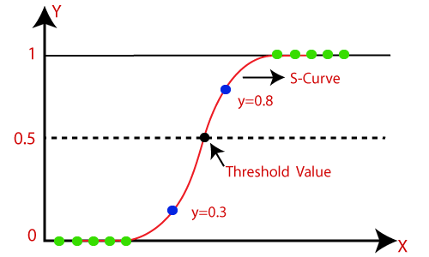

**Fig. 27: Logistic Regression [7]**

**Below are the Results from applying Logistic Regression model:**

**Table 2: Classification Report of LR**

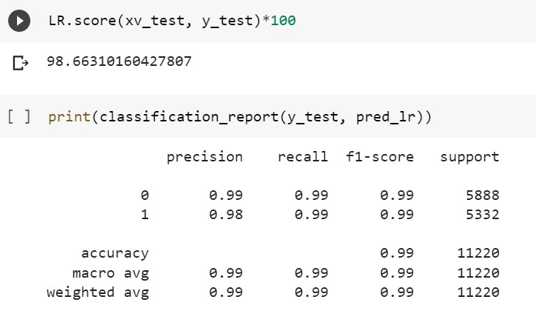

**Confusion Matrix:**

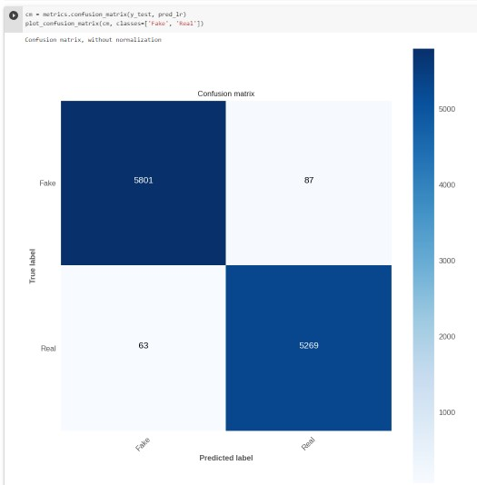

**Fig. 28: Confusion matrix from Logistic Regression**

## Decesion Tree Classification

* For both binary and multi-class classification tasks, decision tree classification is a popular machine learning approach. The input data are recursively divided into subgroups depending on the most instructive characteristic.
* Decision trees can handle category and numerical data and are simple to understand and use. Additionally, they are resistant to noise and missing data and are capable of capturing intricate non-linear correlations between features.

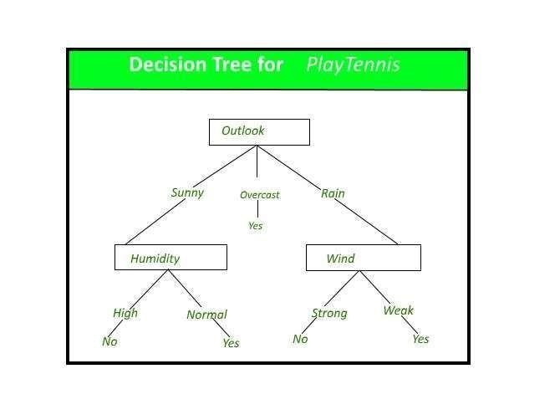

**Fig. 29: Decision Tree [8]**

**Below are the Results from applying Decision Tree Classification model:**

**Table 3: Classification Report from Decision Tree**

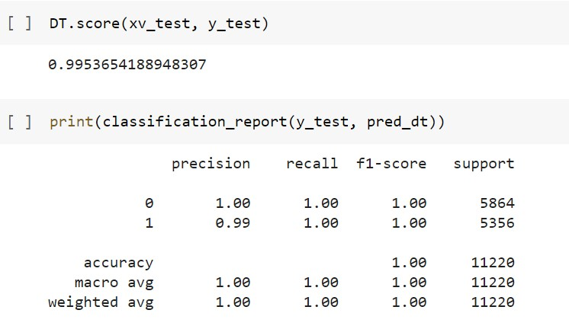

**Confusion Matrix:**

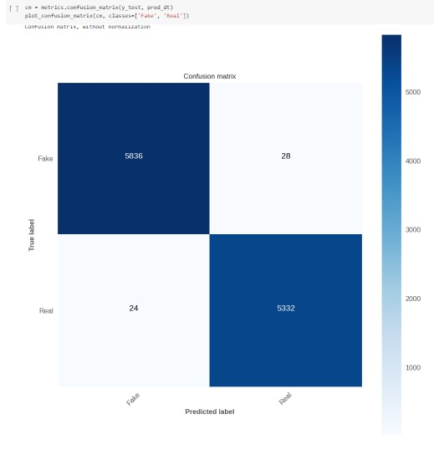

**Confusion Matrix from Decision Tree Classification**

## Gradient Boosting Classifier

* Gradient Boosting Classifier is a powerful algorithm for both classification and regression problems. It works by combining multiple weak models, such as decision trees, to create a strong ensemble model.
* One of the advantages of Gradient Boosting Classifier is that it can handle complex non-linear relationships between features and the target variable. Additionally, it has a built-in mechanism for handling missing data and can automatically select important features for better accuracy. However, it can be computationally expensive and prone to overfitting if not tuned properly.

**Below are the Results from applying Gradient boosting classifier model:**

**Table 4: Classification Report of GBC**

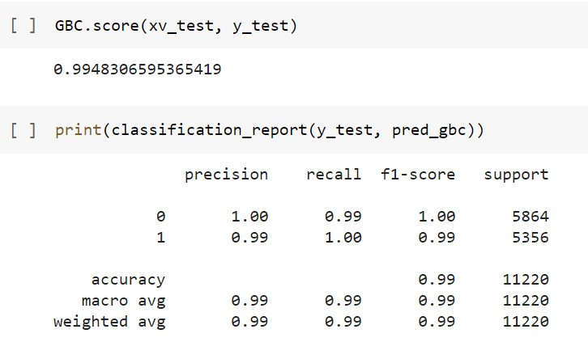

**Confusion Matrix:**

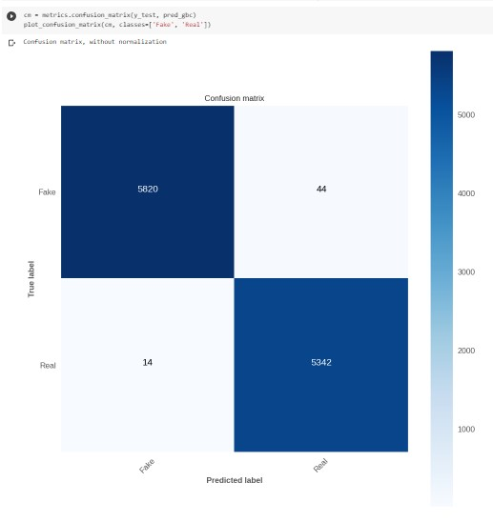

**Fig. 30: Confusion Matrix from Gradient Boosting Classifier**

## Random Forest Classifier

▪As the name implies, a Random Forest consists of numerous independent decision trees that work together as an ensemble. Each tree in the Random Forest spits out a class prediction, and the classification that recieves the most votes becomes the prediction of our model.

**Below are the Results from applying Random Forest Classifier model:**

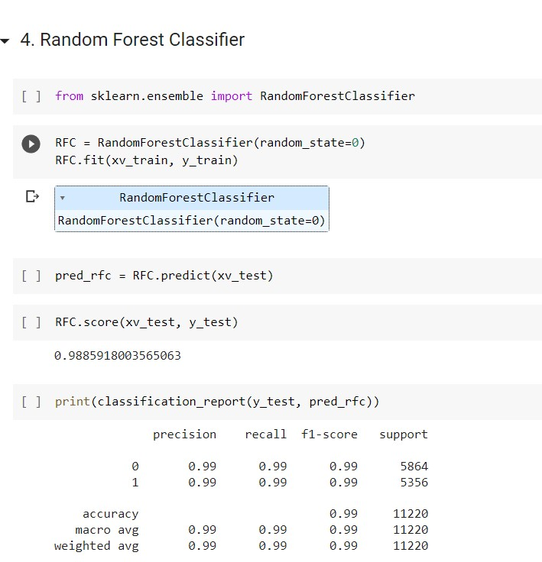

**Table 5: Classification Report of RFC**

**Confusion Matrix:**

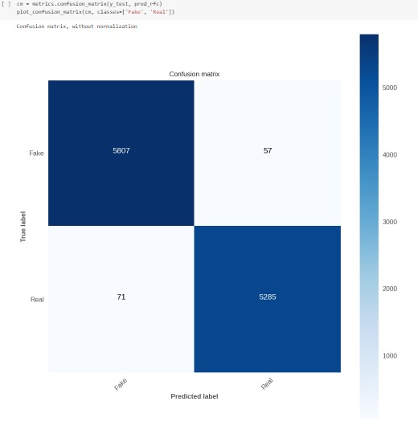

**Fig. 31: Confusion Matrix from Random Forest Classifier**

**Sample Input:**



**Fig. 32: Web Browser Output**

CHAPTER-5 CONCLUSIONS

**___________________________________________**

## 5.1) Conclusions

Considering the accuracy scores, we were able to establish for the various models, it appears that all of the models are doing a good job of identifying false news items. The SVM, Decision Tree, and Gradient Boosting classifiers notably achieved a very high accuracy of 99.5%, although the Random Forest Classifier performed Good over the model, at 98.71% without overfitting.

All things considered, these results suggest that a range of classifiers may be used with equal success rates and that machine learning techniques may be extremely successful in spotting bogus news. It's important to keep in mind that accuracy is only one measure and that the models should be evaluated using multiple metrics including precision, recall, and F1-score in addition to factors like interpretability, scalability, and processing requirements. Investigating different feature extraction and selection methods, classifier types, and ensemble approaches may also be useful to see whether even better results may be produced.

We utilised the datasets real and fake, each of which had 21417 and 23481 entries, respectively. We converted text into a numerical model using TF-ID F Vectorizer and utilised the following models:

Accuracy of 99.31% for support vector machines

Decision Tree: 99.5% precision

Classifier using Gradient Boosting: Accuracy = 99.5%

Accuracy of 98.7% for the random forest classifier

## 5.2) Future Scope

Future research and advancement in the field of false news detection are abundantly possible. Future efforts to identify bogus news may go in the following directions:

**Including more varied and subtle aspects:** For the most part, current methods for detecting false news rely on simple text-based traits like TF-IDF vectors or bag-ofwords. Research in the future could concentrate on more complex and diverse aspects, such sentiment analysis, network analysis, or multimedia analysis (for instance, identifying false images or videos).

**Creating more interpretable models:** Existing methods for spotting fake news sometimes rely on complex machine learning algorithms that might be difficult to comprehend. In the future, it would be beneficial to develop more intelligible models that might provide more information on how people make decisions.

**Combining information from other sources:** In addition to social media, news articles, and videos, fake news is regularly spread through other media channels and platforms. The development of methods that can incorporate data from several sources may be crucial in the future to improve false news identification.

**Adapting to shifting strategies:** It will be crucial for fake news detection technologies to develop alongside the tactics used by those who create and spread it. For this, the detection methods might need to be regularly reviewed and improved.

REFERENCES

**___________________________________________**

1. A. S. A. Ahmed, A. Abidin, M. A. Maarof, and R. A. Rashid, "Fake news detection: A survey," IEEE Access, vol. 9, pp. 113051-113071, 2021. doi:

10.1109/ACCESS.2021.3104178

1. S. Asghar, S. Mahmood, and H. Kamran, "Fake news detection using machine learning: A survey," IEEE Access, vol. 9, pp. 57613-57639, 2021. doi:

10.1109/ACCESS.2021.3075392

1. J. H. Kim, S. H. Lee, and H. J. Kim, "Fake news detection using ensemble learning with context and attention mechanism," IEEE Access, vol. 9, pp. 27569-

27579, 2021. doi: 10.1109/ACCESS.2021.3057736

1. M. F. Hossain, M. M. Islam, M. A. H. Khan, and J. J. Jung, "Fake news detection using hybrid machine learning algorithms," IEEE Access, vol. 8, pp. 233350-

233364, 2020. doi: 10.1109/ACCESS.2020.3041149

1. S. S. Ghosh, A. Mukherjee, and N. Ganguly, "A multi-perspective approach to fake news detection," IEEE Intelligent Systems, vol. 35, no. 5, pp. 31-39, 2020. doi:

10.1109/MIS.2020.3012915

**[6]**https://www.google.co.in/imgres?imgurl=https%3A%2F%2Fdataflair.training%2Fblogs%2Fwpcontent%2Fuploads%2Fsites%2F2%2F2019%2F07 %2FintroductiontoSVM.png&tbnid=p7ua2IdzmLsjqM&vet=12ahUKEwjf26Kfru DAhW6JrcAHdMIAagQMygCegUIARDlAQ..i&imgrefurl=https%3A%2F%2Fd ata-flair.training%2Fblogs%2Fsvm-support-vector-machinetutorial%2F&docid=7oy5_irTaN4UfM&w=801&h=420&q=svm&ved=2ahUKE wjf26KfruD-AhW6JrcAHdMIAagQMygCegUIARDlAQ



**[7]**https://www.google.co.in/imgres?imgurl=https%3A%2F%2Fstatic.javatpoint.c om%2Ftutorial%2Fmachine-learning%2Fimages%2Flogistic-regressioninmachinelearning.png&tbnid=LuaHnfur76i8eM&vet=12ahUKEwjFoPGSruDAh VNnNgFHUjLCl8QMygCegUIARDjAQ..i&imgrefurl=https%3A%2F%2Fwww.j avatpoint.com%2Flogisticregressioinmachinelearning&docid=makIlDmuc8naW M&w=500&h=300&itg=1&q=logistic%20regression&ved=2ahUKEwjFoPGSru

D-AhVNnNgFHUjLCl8QMygCegUIARDjAQ

**[8]**https://www.google.co.in/url?sa=i&url=https%3A%2F%2Fwww.geeksforgeek s.org%2Fdecision-tree%2F&psig=AOvVaw0sYuRq-TZe0WWhW9YQUnl&ust=1683450911500000&source=images&cd=vfe&ved=0CBEQjRxqF woTCLDwi7qt4P4CFQAAAAAdAAAAABAE

APPENDICES

**___________________________________________**

**The following phrases and words are frequently used in legitimate news and can be used to spot fake news:**

* Sources
* Evidence Experts
* Research Statistics Facts ▪ Data Quotes
* Corroborate Verification
* Objective
* Impartial
* Reliable
* Credible
* Transparency
* Context Timeliness
* Accuracy
* impartial reporting
* several perspectives

**Certainly, here are some commonly used words and phrases that may indicate the presence of fake news:**

* Allegedly
* Supposedly
* Claims
* "Fake news" or "hoax"
* Conspiracy
* Unverified
* Sensational
* Emotional
* Outrageous
* Shocking
* Clickbait
* Exaggerated
* Biased
* Partisan
* Misleading
* Inaccurate
* Unsubstantiated
* Rumors
* Speculation
* Opinions presented as facts.